CONFIDENCE Dissemination workshop

Coping with uncertainties for improved modelling
and decision making in nuclear emergencies

2-5 December 2019, Bratislava, Slovak Republic

Location, Transport and Accommodation Information
Venue
The CONFIDENCE Dissemination workshop will take place at Lindner Hotel Gallery Central, Metodova 4, Bratislava, Slovak Republic.
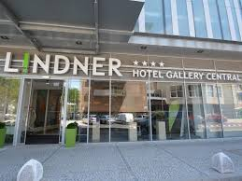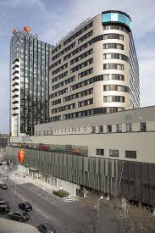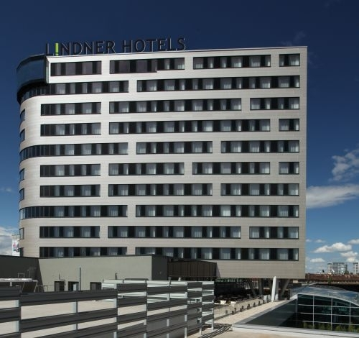
Located right next to the Trnavske Myto transportation hub, this Lindner’s hotel offers convenient connections both to Bratislava Old Town within 2.5 km and to Bratislava Airport 7 km away. The main bus and train station are both reachable in 3 km.
The map below shows the location and transport connection by busses within Bratislava.
For more information use the Lindner Hotel official web site https://www.lindner.de/en/bratislava-hotel-gallery-central/welcome.html

Transportation to Bratislava

By Taxi
For the Taxi transfer we recommend to use Limotransfer and use the link http://limotransfer.sk/ or phone +421 948 046 046 to arrange the taxi.
For the general Taxi please make the reservation at one of the following links:
http://www.transportschwechat.sk/en/
http://www.city-airport-taxis.com/airporttransfers/city/Vienna-taxi?gclid=CMOHicil_7gCFcFV3god0TwA_Q

FROM VIENNA INTERNATIONAL AIRPORT TO BRATISLAVA BY BUS
The easiest way how to get to Bratislava is to take bus from terminal in Vienna international airport.
There are regular buses operating from Vienna airport to Bratislava bus station https://www.viennaairport.com/en/passengers/arrival__parking/bus_connections
Location: Bus stop (3 or 4) in front of arrival hall in Vienna airport.
Schedule: bus goes every hour/half an hour each day, get off the bus at the stop called Bratislava bus station – Autobusova Stanica (AS), Mlynské Nivy.
Ticket purchase: tickets are available via mobile app or on-line at links to particular bus line or directly from bus driver when entering the bus (if available); ticket costs ~7 EUR, estimated time of travelling is 1 hour.

TRANSPORTATION WITHIN BRATISLAVA
Transport connection within Bratislava by bus is given at following map:
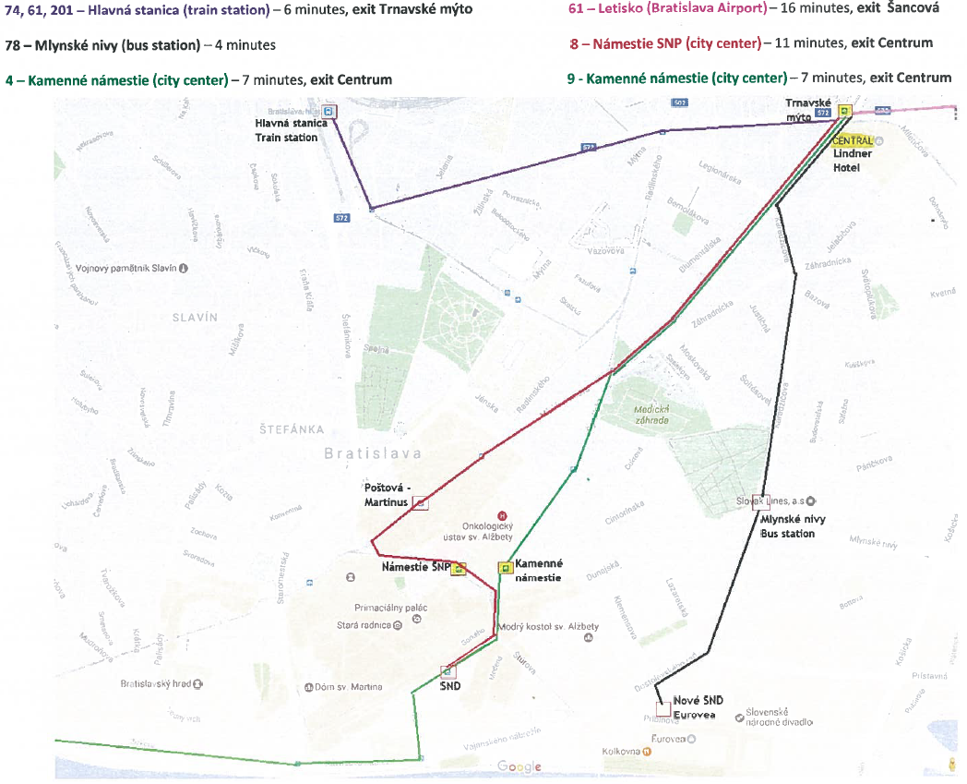

Accommodation
We recommend you accommodation directly in the Lindner Hotel Gallery Central.
The deadline for reservation is 30.09.2019. After this date hotel cannot guarantee availability of rooms and rates. Reservation will be confirmed up to the actual room availability.
Please use the attached reservation form for booking an accommodation as hotel accepts only this reservation forms for CONFIDENCE dissemination workshop participants and send it to the e-mail address reservations.bratislava@lindnerhotels.com or by fax at number +421 2 3993 0001. For any questions please contact directly the hotel representative at numbers +421 2 3993 0004/5.